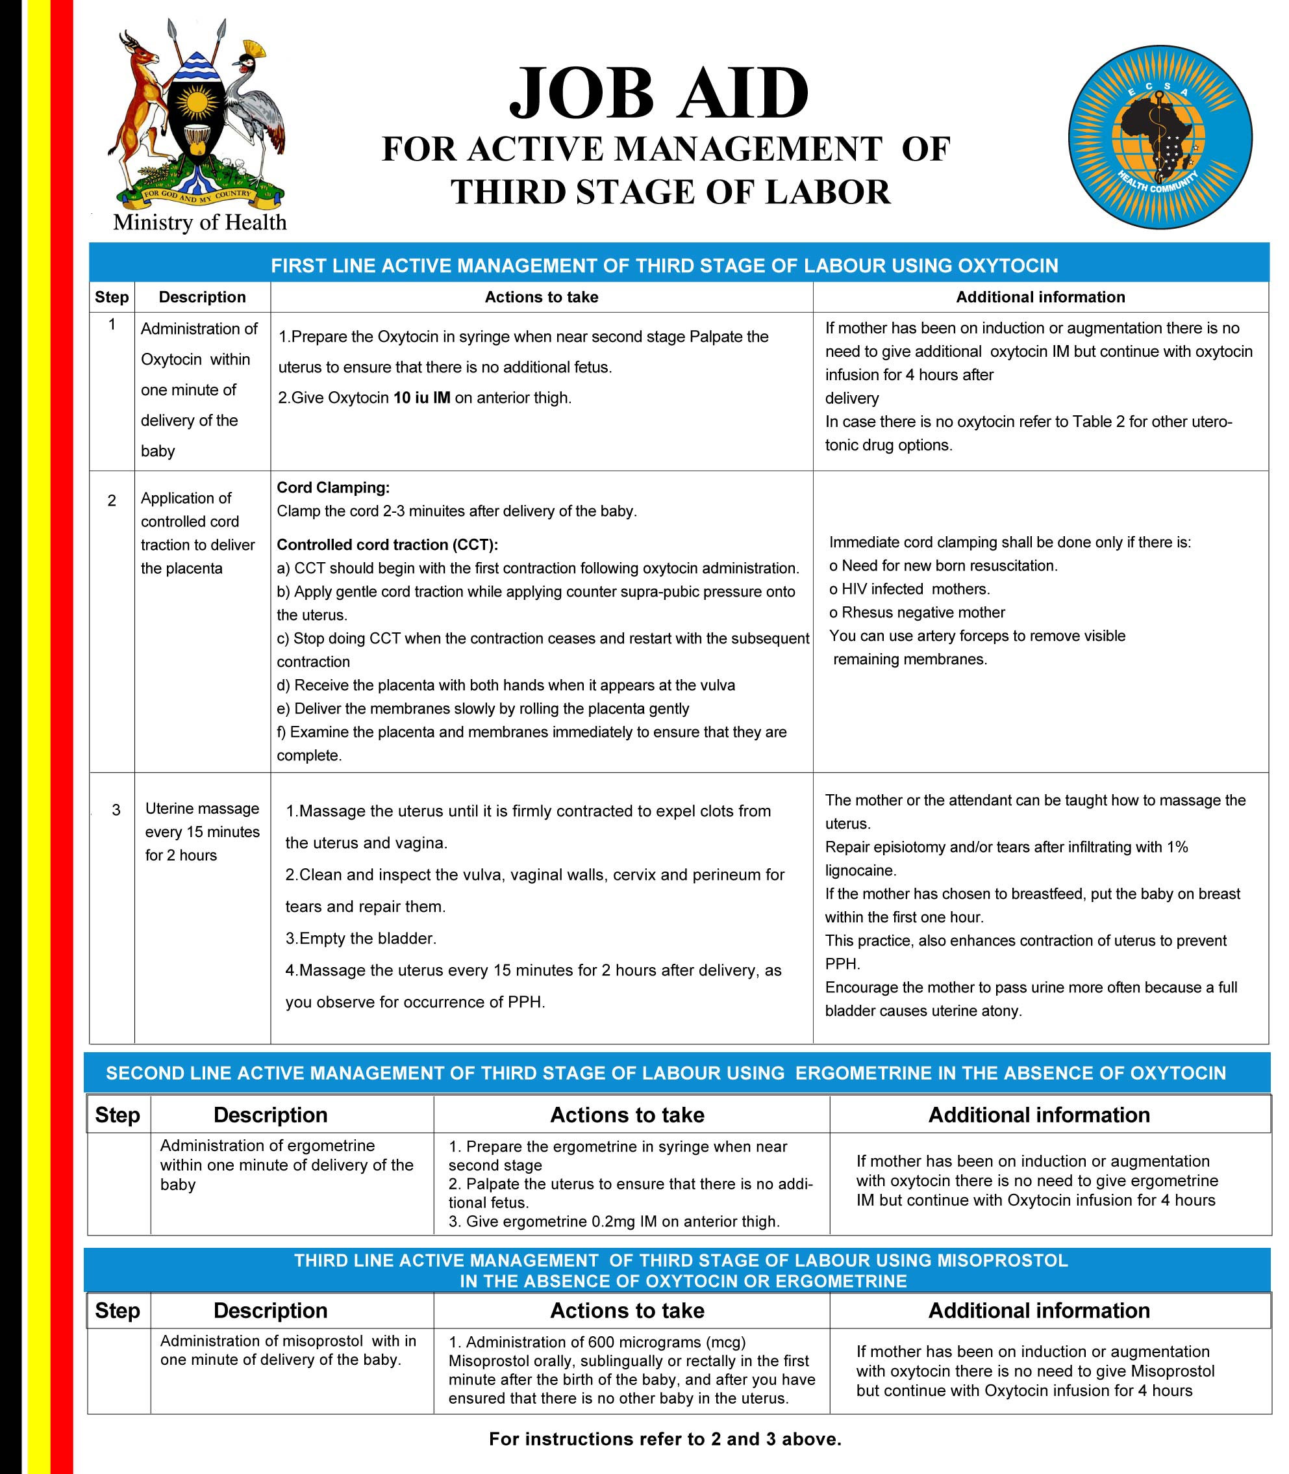

**EAST, CENTRAL AND SOUTHERN AFRICA HEALTH COMMUNITY**

**Vacancy Announcement**

**College of Surgeons of the East, Central and Southern Africa (COSECSA).**

**Title:** Managing Editor

**Reports to:** Editor in Chief and the Chief Executive Officer

1. **Background of the Organization**

The East, Central and Southern Africa Health Community (ECSA-HC) is a regional organization set up in 1974 to foster cooperation leading to the strengthening of health programs in the region and promote attainment of the highest possible standards of health in its member countries. The Member States of the ECSA Health Community are Kenya, Lesotho, Malawi, Mauritius, Eswatini Tanzania, Uganda, Zambia and Zimbabwe.

1. **Background of the College of Surgeons for the East, Central and Southern Africa (COSECSA).**

The College of Surgeons for the East, Central and Southern Africa (COSECSA) is a professional body that fosters postgraduate education in surgery. The college delivers a common surgical training programme with a common examination and an internationally recognized surgical qualification. The primary objective is to advance education, training, standards, research and practice in surgical care in the ECSA region. The College currently operates in 14 countries in the Sub-Saharan region: Kenya, Botswana, Burundi, Ethiopia, Malawi, Mozambique, Namibia, Rwanda, South Sudan, Sudan, Tanzania, Uganda, Zambia and Zimbabwe.

1. **Overall Purpose of the Job:**

The Managing Editor will be responsible for overseeing the day-to-day operations of the East and Central African Journal of Surgery (ECAJS), ensuring the timely and quality publication of manuscripts. The Managing Editor will oversee the daily management of all submissions within the manuscript system, tracking timelines, upholding editorial standards, and addressing inquiries from stakeholders when necessary.

The Managing Editor will work closely with the COSECSA secretariat staff to provide support in updating COSECSA’s database and any other research related matters. With the secretariat, the Managing Editor will assist the Editor-in-Chief in preparing reports and keeping track of journal metrics related to submissions, readership/website usage, budgeting for the journal, and citations and report such statistics and trends to the editor in chief and editorial board to guide editorial, publishing, and marketing strategies and policies. He/she will also work with the Chair of the COSECSA Institutional Review Board (IRB) to support trainees and external researchers in their requests for ethics advice and review.

1. **Duties and Responsibilities:**
   1. **Editorial management:**

a. Lead the operation of an online manuscript management platform (e.g. Open Journal Systems) integrated with the main journal website.

b. Support the Editor-in-Chief and editors in all publication activities, ensuring robust peer-review processes.

c. Act as a point of communication for the editorial board, maintaining minutes of editorial meetings, and coordinating journal-related activities.

* 1. **Article Processing**

a. Manage pre-submission inquiries and communicate with authors

b. Receive articles sent for consideration of publication to the journal and complete the prereview checklist (check plagiarism and submission guidelines). If satisfactory, forward to the editor-in-chief to determine if appropriate for peer review.

c. Maintain a database of peer reviewers, identify and invite appropriate peer reviewers for articles (with editor), and manage the peer review process.

d. Compile reviews and recommendations and propose language for the decision letter to authors (eg, major or minor revision, additional peer review required or not) for the Editor.

e. Communicate with authors regarding decisions reached as directed by the Editor-in Chief and editors.

* 1. **Production Oversight**

a. Copyedit articles for publication including language editing and proofreading and perform typesetting/XML conversion and all necessary tasks for production.

b. Ensure that each publication cycle is completed on time and meets expected publication standards, ready for dissemination in online formats

c. Guide articles through the editorial process, from submission to final publication, in line with PUBMED standards and indexing requirements.

d. Archive articles and register for ECAJS digital object identifiers for individual articles.

* 1. **Quality Assurance**

a. Proofread and verify the accuracy of articles, ensuring compliance with the highest standards of scientific reporting and editorial integrity.

b. Maintain responsibility for the final check of the layout of articles, including figures and tables, before publication.

c. Oversee the integration of new technologies and platforms that can streamline the publication process and enhance the reader and author experience.

d. Ensure publications to meet PUBMED standards, with the aim of acquiring PUBMED indexing for the ECAJS

* 1. **Platform Management**

a. Manage the manuscript submission system (e.g. Open Journal Systems), improving it as necessary for efficiency and user satisfaction. This platform is to be integrated into the main COSECSA website.

b. Ensure the integration of the manuscript management system with the broader journal and society databases.

c. The Managing Editor will assist authors, reviewers, and editors to navigate the submission system and process to ensure a seamless user experience.

* 1. **Compliance and Ethics**

a. Uphold the highest ethical standards of publication, addressing any issues concerning authorship, plagiarism, and research misconduct.

b. Implement policies in line with industry-standard ethical guidelines from ICMJE and COPE.

c. In coordination with the authors, ensure rights to use materials from other publications or sources.

* 1. **Outreach and Development**

a. Engage with the surgical community to raise the profile of the journal, encouraging submissions and promoting published articles.

b. Effectively use social media to highlight activities of the journal. Lead public engagement using social media tools like Facebook, Twitter, and LinkedIn, and other online tools, such as, Research Gate and Mendeley.

c. Monitor and report on submission trends, citation metrics, impact factors, and other analytics that are important for the strategic planning and positioning of the journal.

d. Work closely with the Editor-in-Chief to commission high-quality content and attract leading figures in the field to contribute and create a positive experience for peer reviewers.

1. **Qualifications and Work Experience**
   1. **Education**
2. A BSc in Social Sciences or natural Sciences (preferably library sciences, literature, Language or relevant fields)
3. A Master's degree in public health or related field would be an added advantage
   1. **Work Experience and Knowledge**
4. At least 5 years of relevant, progressive experience in journal management
5. Minimum of two years at a scientific journal as managing editor or assistant editor
6. 2-4 years’ experience of conducting clinical research in health/education fields in sub-Saharan Africa
7. Strong background in medical publishing and experience with peer-review processes
8. Demonstrated track record and experience in scientific journal management
9. Experience on ethical conduct of research and data access protocols
10. Experience in data management and analysis
11. Familiarity with the global surgery/global health community in Sub-Saharan African and globally
12. **Essential Skills and Competencies Required**
13. Excellent working knowledge of standard IT systems and databases
14. Experience in developing and implementing systems and processes
15. Experience using other research software (such as SPSS, R, Redcap and Stata) and data visualisation software (such as Power BI and Tableau).
16. Demonstrate poise, tact, integrity, and professionalism
17. Excellent written and oral communication skills, with a high level of accuracy
18. Excellent knowledge of report writing and presentation skills.
19. Excellent organizational and time management skills
20. Capacity and experience to work in a multicultural environment
21. Capacity to perform multiple tasks and work under pressure
22. **Language**

Fluency in both spoken and written English

1. **Age**

Applicants must be aged between 25 and 40 years of age.

1. **Contract Appointment;**

This will be a two-year contract appointment renewable upon satisfactory performance and subject to the availability of funds.

1. **Remuneration Package**

An attractive package at the Assistant level will be offered to the right candidate.

1. **Method of Application**

Nationals of members States who wish to apply for the Post should do so by submitting the following:

1. Brief Application Letter stating why the candidate feels suitable for the Post
2. Detailed Curriculum Vitae.
3. Completed Application form for ECSA-HC posts (available under vacancies/opportunities jobs on www.ecsahc.org
4. **Certified** copies of Educational and Professional Certificates
5. Names of three (3) referees with their addresses including telephone and e-mail

*Applications that have not met all of the above set criteria will not be accepted. Only candidates who have met all the requirements of the post and have been selected for an interview will be contacted.*

**Applications should reach the address below by 31st December 2023.**

The Director General

East, Central and Southern Africa-Health Community

Plot 157 Oloirien, Njiro Road

P.O. Box 1009

Arusha, Tanzania

E-mail: [vacancies@ecsahc.org](mailto:vacancies@ecsahc.org) with copies to [regsec@ecsahc.org](mailto:regsec@ecsahc.org); [doid@ecsahc.org](mailto:doid@ecsahc.org%20) ;

Website: [www.ecsahc.org](http://www.ecsahc.org)

**The ECSA Health Community is an equal opportunities employer. Female candidates are particularly encouraged to apply**